SOP Printing a test page

From time to time, you may wish to print a test page on a printer, for example, after   
changing toner or printer ink, or after changing the print driver. In those cases, the test page helps you to ensure that the printer is working properly.

Getting ready

For this recipe, you print a test page on the Sales Group object's LaserJet printer, as   
updated by the "*SOP Changing printer drivers"*.

How to do it:

1.Get the printer objects from WMI:

$Printers = Get-CimInstance -ClassName Win32_Printer

2.Display the number of printers defined:

'{0} Printers defined on this system' -f $Printers.Count

3.Get the Sales Group printer:

$Printer = $Printers | Where-Object Name -eq "SGCP1"

4.Display the printer's details:

$Printer | Format-Table -AutoSize

5.Print a test page:

Invoke-CimMethod -InputObject $Printer -MethodName PrintTestPage

How it works:

In *step 1*, you use Get-CimInstance to return all the printers defined on this system. In *step* *2*, you display the total printers defined:



In *step 3*, you get the printer object corresponding to the Sales Group LaserJet printer. In *step 4*, you display the details of this printer:

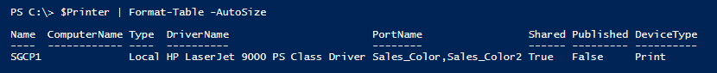

In *step 5*, you invoke the PrintTestPage method on the Sales Group LaserJet printer,   
which then generates a test page on the printer. If you are using the printer MMC snap-in, the printer test page looks like this:

